# Machine Learning Lab 1

Junming Zhang 29299527 [jz1g17@ecs.soton.ac.uk](mailto:jz1g17@ecs.soton.ac.uk)

Problem 1

Answer:

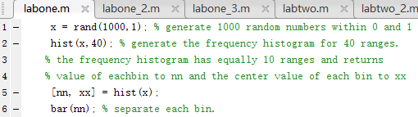

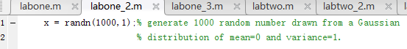

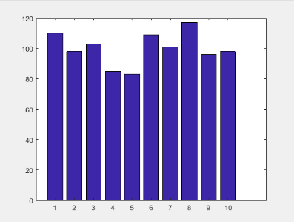 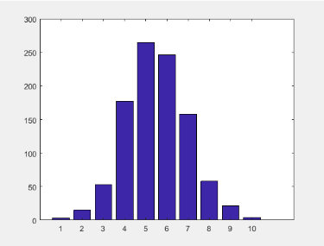

Figure 1.1: result of labone.m Figure 1.2: result of labone_2.m

It could find ‘rand’ command is uniform distribution and ‘randn’ is Gaussian distribution.

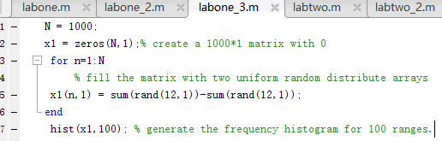 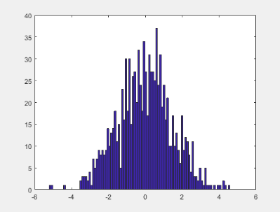

Figure 1.3: result of labone_3.m

It could find the result is similar to a Gaussian distribution. Due to the central limit theorem, in most situations, when independent random variables are added, their properly normalized sum tends toward a normal distribution.

Problem 2

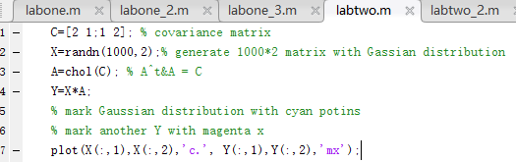 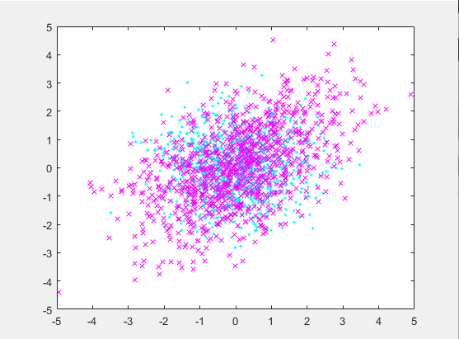

Figure 1.4: result of labtwo.m

This is using a linear transformation to generate the multivariate normal distribution. The n-dimensional random variable is normal distribution N(u,B), suppose m dimensional random variable Y is the linear transformation of X, it means Y=XC, C is a n*m matrix, therefore Y is m dimensional normal distribution N(Uc,C’BC).

In this case, using Cholesky decompose to a covariance matrix and multiply a normal distributed matrix can obtain a linear correlated or negative correlated distribution which like figure 1.4.

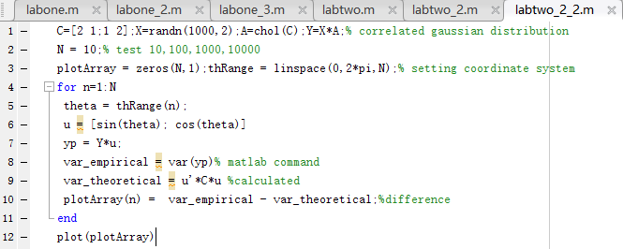

The curve will smooth with the increasing N from 10,100,1000,10000.

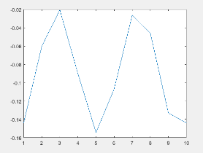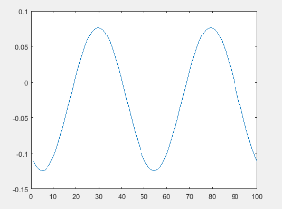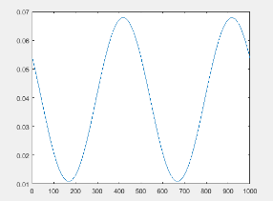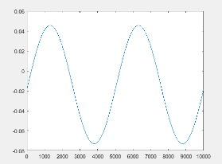

Figure 1.5: result of labtwo2_2.m

$A-λE=\left|\begin{matrix}2-λ & 1 \\ 1 & 2-λ\end{matrix}\right|={\left(2-λ\right)}^{2}-1=3-4λ+λ^{2}=(λ-1)(λ-3)$

Therefore, the eigenvalue of A is $λ_{1}=1$ and $λ_{1}=3$

When $λ_{1}=1$, $\left|\begin{matrix}1 & 1 \\ 1 & 1\end{matrix}\right|$ $\begin{matrix}x_{11} \\ x_{12}\end{matrix}=\begin{matrix}0 \\ 0\end{matrix}$*, so $x_{11}={-x}_{12}$ and the eigenvector is $\begin{matrix}1 \\ -1\end{matrix}$

When $λ_{1}=3$, $\left|\begin{matrix}-1 & 1 \\ 1 & -1\end{matrix}\right|$ $\begin{matrix}x_{11} \\ x_{12}\end{matrix}=\begin{matrix}0 \\ 0\end{matrix}$*, so $x_{11=}x_{12}$ and the eigenvector is $\begin{matrix}1 \\ 1\end{matrix}$